2.1.1 What is the value of variable result after running following commands?



Answer is: -1.25

2.1.2 What is the value of variable result after running following commands?

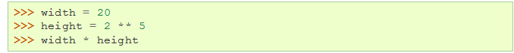

Answer is: 640

2.1.3 What is the last value printed in the interpreter? And what is the meaning of _ in the last line?

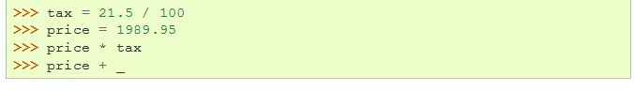

Answer: the outcome is the tax, the meaning of _ is that you still have to add up the last used line into the value you are using

2.1.4 What is the type of variable result after running following code?



Answer: you get decimal number

2.1.5 What is the difference between the following code? And what is each one output?

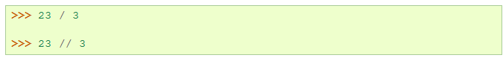

Answer: the first one has decimals in it and the second one is just rounded on the 7

2.2.1 What will be the outputs in the code below?

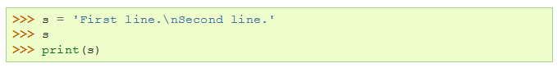

Answer: the lines get underneath each other like you see because of the \n thing in between of them

2.2.2 What will be the output in the code below?

Answer: the first it think it has \n of the directory so it think its ame in the end and the other one its knowing by the r that it’s a full name.

2.2.3 produce the following output:

2.2.4 following code has an error. What is the error? And how you can fix it to print “Mikaeil Shaghelani”?



Answer: is to make the second first name into last name value, than if you just print first name + last name it will be stuck to each other to give it space we add ‘ ’ to give it space between each other.

2.2.5 what will be printed on the screen?

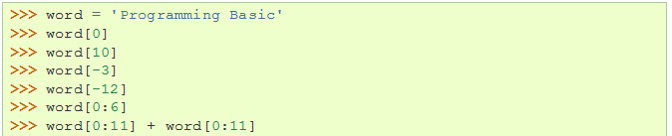

Answer: it look at letter so for example 0 is the first letter in programming basic, and in the end it takes all letters of programming and adds it up into programming again.